Step 1:

Data cleaning: bandpass filtering (0.1-30 Hz) of EEG channels

Data selection: using the trigger signal

MATLAB file: filtroEEG.m

Step 2:

Feature extraction:

various statistical measures in different band frequencies:Figure 1: features extracted


MATLAB file: EEGyesAllFeatures.m

EEGnoAllFeatures.m

Step 3:

Feature Selection:

top k-best score with ANOVA analysis and F-test

Step 4:

Model:

Hard margin SVM with linear kernel, C=1. (Note: since the smallness of the dataset, the performances of the model vere assessed with a full search using leave-p-out method with p = 1,2,3)

Step 5:

Results: k = 21, leave-3-out: 96% accuracy

accuracy varying train/test dimensions (figure) (note: error bars are standard devi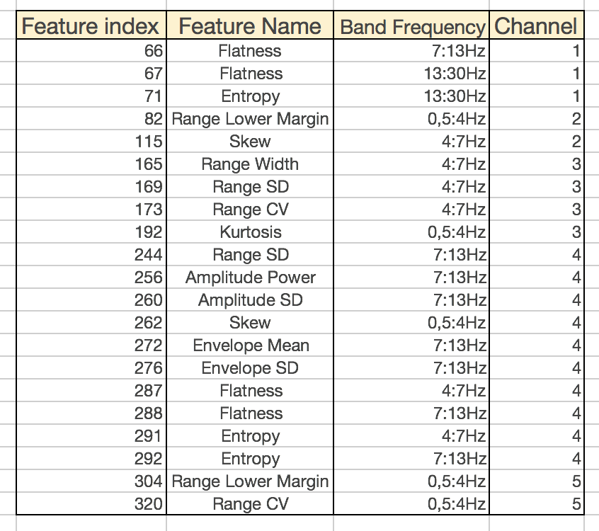ation of the results of 5000 experiments with different sampled instances given the train/test fraction)

The 21 features selected are: